NOTICE OF CANCELLED MEETING
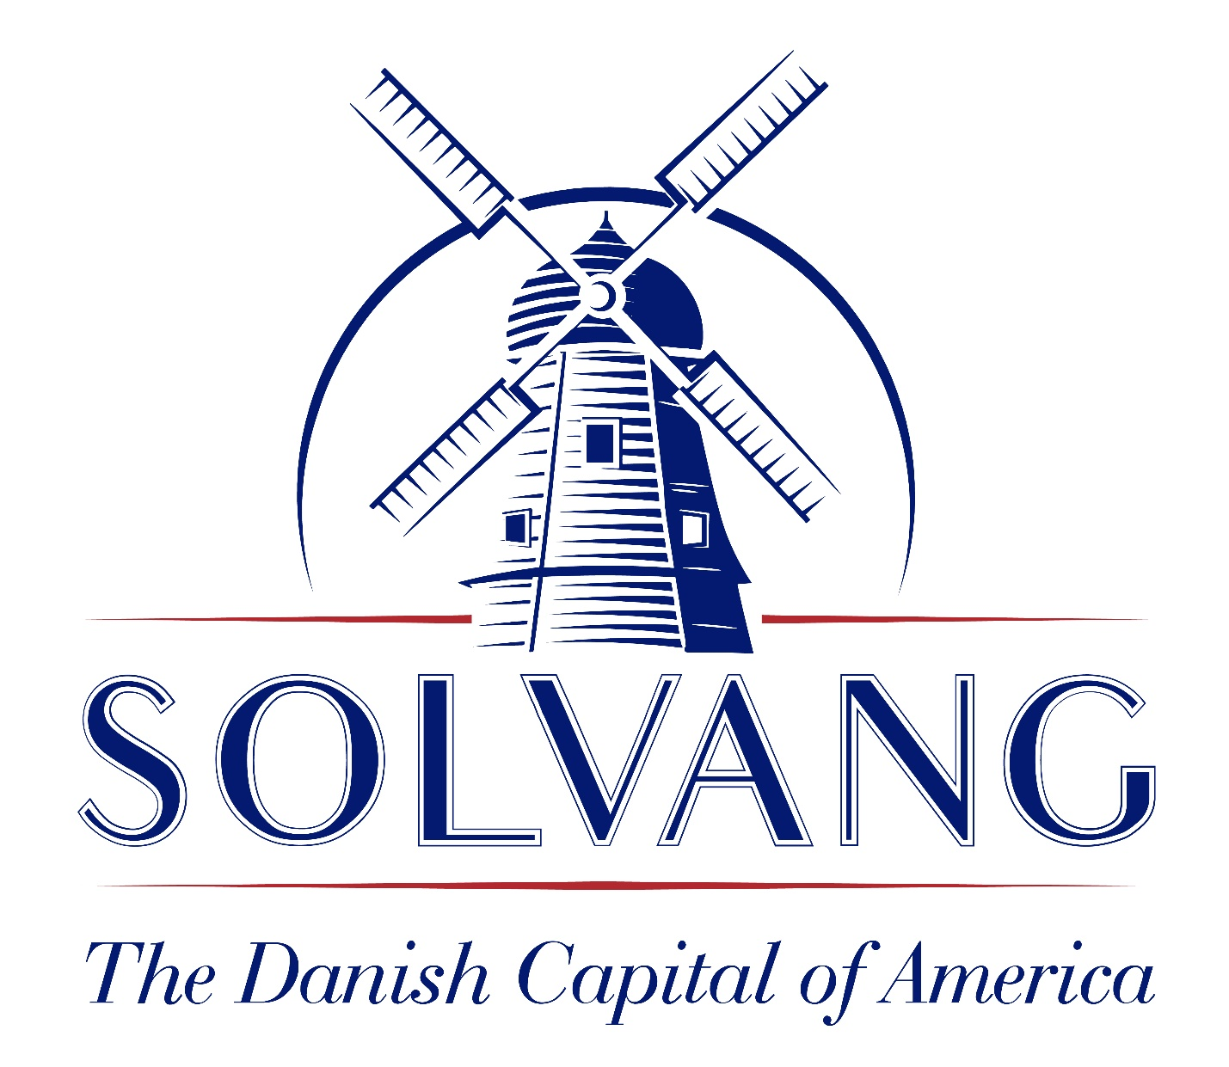
TOURISM ADVISORY COMMITTEE

Notice is hereby given that the Solvang Tourism Advisory Committee meeting of May 4, 2023 is cancelled due to lack of business.

Annamarie Porter, City Clerk
Date: April 28, 2023

