NOTICE OF CANCELLED MEETING
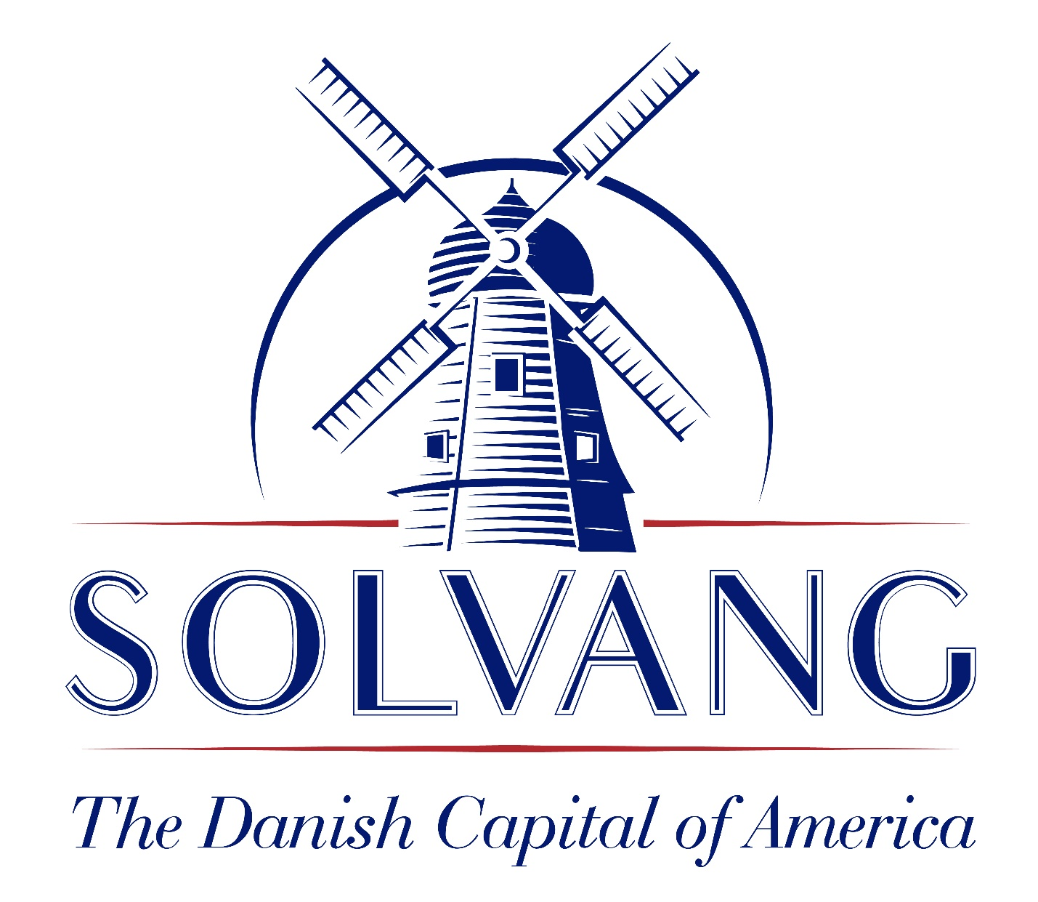
TOURISM ADVISORY COMMITTEE

Notice is hereby given that the Solvang Tourism Advisory Committee meeting of January 5, 2023 is cancelled due to lack of business.

The first meeting of 2023 is scheduled for Thursday, February 2, 2023, at 3:30 p.m. in the Council Chamber of the Solvang Municipal Center, 1644 Oak Street, Solvang, California.

Annamarie Porter, City Clerk
Date: January 2, 2023

